**LAB REPORT NO 9**



**CSE-206L Electronic Circuits Lab**

Submitted by:  **Muhammad Ali**

Registration No: - **19PWCSE1801**

Class Section: A

“On my honor, as student of University of Engineering and Technology, I have neither given nor received unauthorized assistance on this academic work.”

Submitted to:

**Engr. Abdullah Hamid**

Data:(04,07,2021)

Department of Computer Systems Engineering

University of Engineering and Technology, Peshawar

**For 2N3904: -**

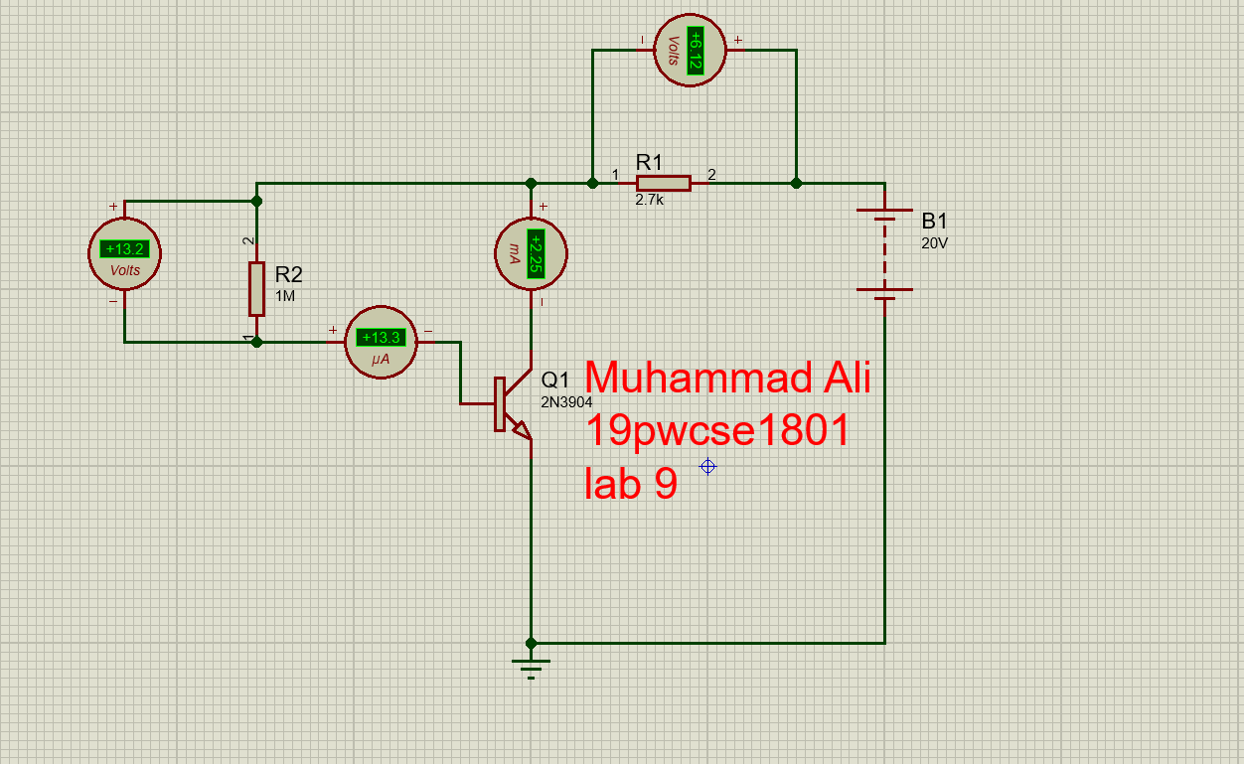

**For 2N4401: -**

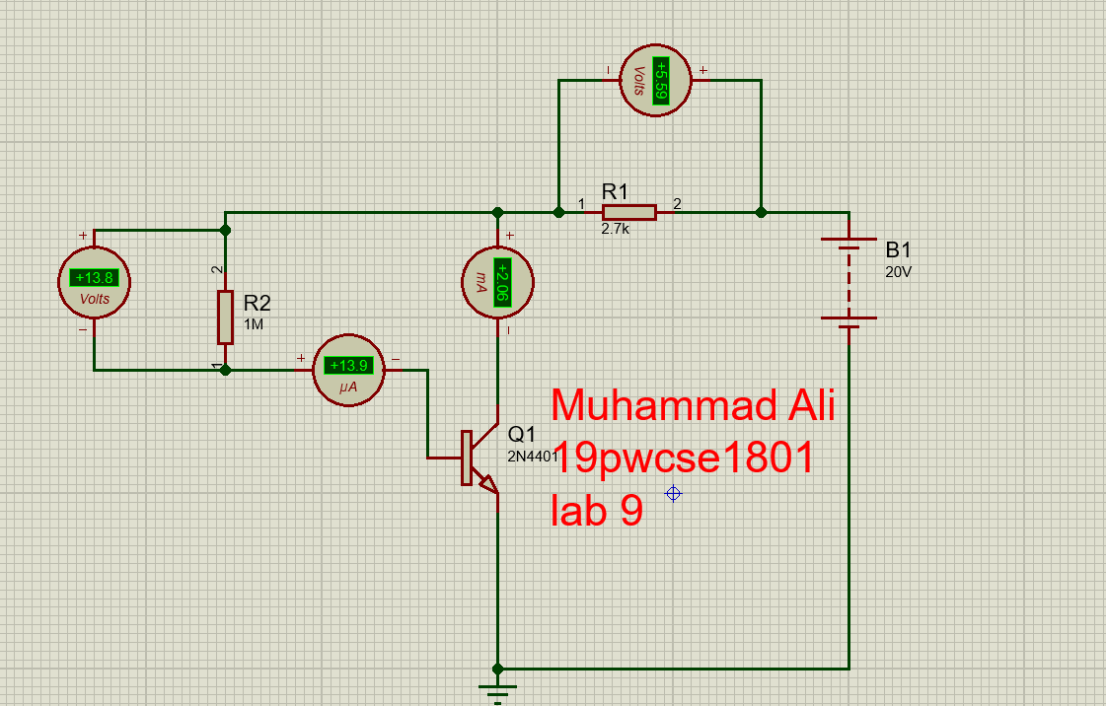

**Calculation: -**

**For 2N3904:-**

**To find VCE and beta, β: -**

VCE = VDC – VCC

VCE = 20V – 6.12V

VCE = 13.88V

β (3904) = IC / IB

=2.25mA / 13.3µA

β (3904) = 169

**For 2N4401: -**

**To find VCE and beta, β: -**

VCE = VDC – VCC

VCE = 20V – 5.59V

VCE = 14.41V

β (4401) = IC / IB

=2.06mA / 13.9µA

β (4401) = 148

IE= IB+IC

= 2.25mA+13.3µA

=0.0135

**Reading B, IB, IC, VCE: -**

|  |  |  |  |  |
| --- | --- | --- | --- | --- |
| **Transistor** | **IC** | **IB** | **VCE** | **β** |
| **2N3904** | 2.25mA | 13.3µA | 13.88V | 169 |
| **2N4401** | 2.06mA | 13.9µA | 14.41V | 148 |

**Change in Beta,** β**: -**

Change in Beta, β =| (β (4401) - β (3904) )|*100 / beta(3904)

Change in Beta, β = |(β (4401) - β (3904) )|*100 / beta(3904)

Putting values

Change in Beta, β = |(148 - 169)| *100 / 169

Change in Beta, β = 12.42